 | American International University-Bangladesh (AIUB)  Faculty of Engineering  Department of Electrical and Electronic Engineering
Course Name: | Microprocessor and Embedded System | Course Code: | EEE 4103
Semester: | Fall 2025-26 | Term: | Mid
Faculty Name: | Dr. Md. Rukonuzzaman | Assignment #: | 02

Course Outcome Mapping with Questions
Item | COs | POIs | K | P | A | Marks | Obtained Marks
Q1-4 | CO1 | P.a.4.C3 | K4 | P1, P3, P7 |  | 2.0×5
Total: |  |  |  |  |  | 10

CO/  CLO Number | CO/CLO Statement | K | P | A | Assessed Program Outcome Indicator | BNQF Indicator | Teaching-Learning Strategy | Assessment Strategy
CO1 | Apply knowledge of microprocessors and microcontrollers to configure different modules of a microprocessor or microcontroller-based system as per given specifications and perform in-depth analysis to optimize the performance of the designed system utilizing the basic concepts and properties of a microcontroller. | K4 | P1, P3, P7 |  | P.a.4.C.3 | FS.2 | Lecture/  Discussion/Q&A | Midterm Assignment 2

Student Information:
Due Date: | 18/11/2025 |  |  |  |  |  |  |  |  |  | Submission Date: |  | 21/11/2025
Student Name: | Mashkur Ibtesham Wazed
Student ID #: | 2 | 3 |  | 5 | 4 | 2 | 6 | 6 |  | 3 | Department: | CSE | Section: | O
 | p | q | - | a | b | c | d | e | - | r

Other Members of the Group |  |  |  | Group #: | 06
Sl. # | Student ID # | Student Name | Department | Signature
 | 23-54270-3 | Arfanul Hoque Nehal | CSE
 | 22-48056-2 | Chinmoy Guha | CSE

Marking Rubrics (to be filled by Faculty):
Problem # | Excellent  [9-10] | Proficient  [7-8] | Good  [5-6] | Acceptable  [3-4] | Unacceptable  [1-2] | No Response  [0] | Secured Marks
 | Detailed unique response explaining the concept properly and the answer is correct with all works clearly shown. Simulations results are produced with no errors. | Response with no apparent errors and the answer is correct, but the explanation is not adequate/unique. Simulations results are produced with minute errors. | The response shows an understanding of the problem, but the final answer may not be correct for all problems. Simulations results are produced with some errors. | All the problems are partially solved; the response indicates part of the problem was not understood clearly or not solved, a few simulation results are shown with errors. | Unable to clarify the understanding of the problem and method of the problem solving was not correct, all problems are not solved, no simulations results are produced. | No Response/ copied from others/identical submissions with gross errors/ image file printed
Comments |  |  |  |  |  | Total marks (10)

- In a biscuit factory, a control system has been designed based on an Arduino Uno microcontroller. This system transfers the biscuit packets at a regular time interval to the conveyor belt from the biscuit-making machine. It was found that the Timer modules in the Arduino Uno are perfect candidates for counting the number of biscuit packets being transferred to the conveyor belt correctly and appropriately. Compute the number of biscuit packets being transferred using the Timers within the following time intervals (Timer0 or Timer1 may be used as needed).
- 30 ms
- 542 ms
Assume that the Arduino system clock has been set at 13 MHz and the available pre-scalers of the system are 1, 8, 64, 256, 512, and 1024. Comment on why and how the required counts are possible to implement using Timer0 or Timer1. Write down the program codes for the Arduino board. Show the simulation results using Proteus.

Answer:
- For 30ms interval,
pre-scaler = 1024
count = ((30*10⁻³)*(13*10⁶))/1024)-1 = 379.85 ~ 380

Timer0 max count = 255 < required count, Timer0 not applicable.
Timer1 max count = 65525 > required count, Timer1 is applicable.

Code –
const int BISCUIT = 8;
int biscuit_out = 1;

void setup() {
pinMode(BISCUIT,OUTPUT);
TCCR1A = 0b00000000;
TCCR1B = 0b00000101;
TCNT1 = 0;
}

int delay_timer(int final_count) {
int count = 0;
while(1) {
if (TCNT1 >= 380) {
TCNT1 = 0;
count++;
if(count == final_count) {
count = 0;
break;
}
}
}
return 0;
}

void loop() {
digitalWrite(BISCUIT, HIGH);
delay_timer(biscuit_out);
digitalWrite(BISCUIT, LOW);
delay_timer(biscuit_out);
}

Proteus Simulation –
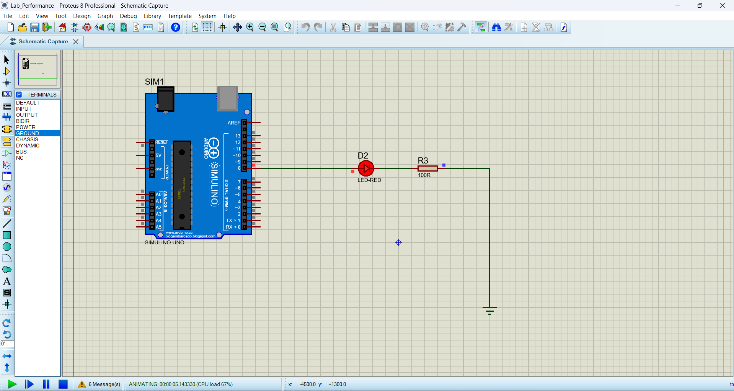
Fig 1: LED on

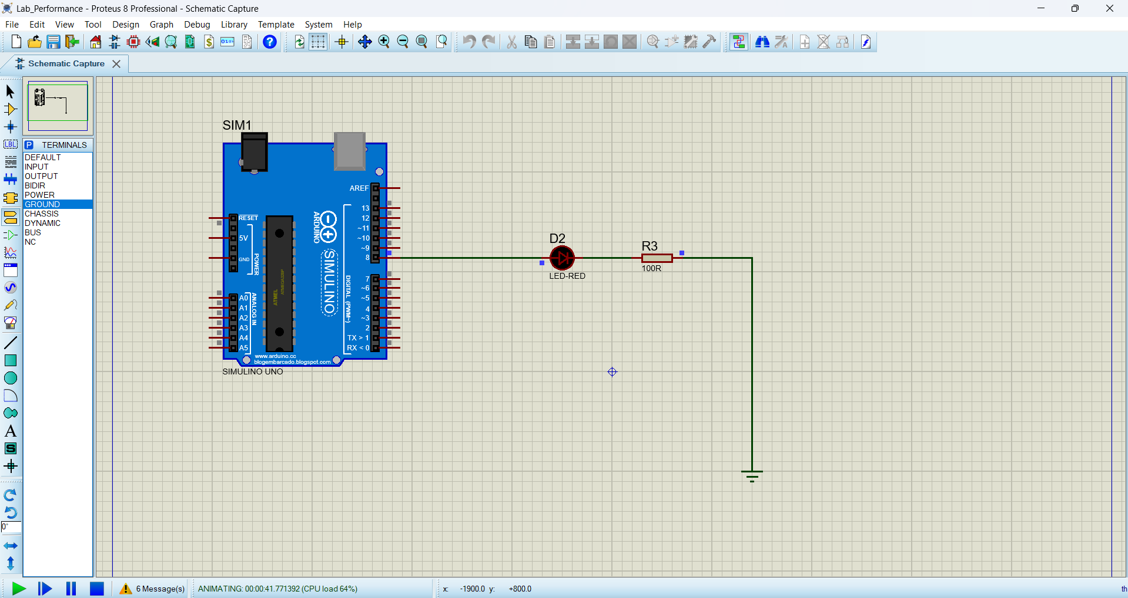
Fig 2: LED off

- For 542ms interval,
pre-scaler = 1024
count = ((542*10⁻³)*(13*10⁶))/1024)-1 = 6879.85 ~ 6880

Code –
const int BISCUIT = 8;
int biscuit_out = 1;

void setup() {
pinMode(BISCUIT,OUTPUT);
TCCR1A = 0b00000000;
TCCR1B = 0b00000101;
TCNT1 = 0;
}

int delay_timer(int final_count) {
int count = 0;
while(1) {
if (TCNT1 >= 6880) {
TCNT1 = 0;
count++;
if(count == final_count) {
count = 0;
break;
}
}
}
return 0;
}

void loop() {
digitalWrite(BISCUIT, HIGH);
delay_timer(biscuit_out);
digitalWrite(BISCUIT, LOW);
delay_timer(biscuit_out);
}

Proteus Simulation –

Fig 3: LED on


Fig 4: LED off

- (a) A TV remote controller is to be designed for the selection of channels. The channel selection buttons are required to be debounced, that is, one press must cause the remote to change to the subsequent channel. It was observed that the switches exhibit bounce times well under 4ms and the duty cycle is 50%. Design a circuit using the 74HC14 Schmitt trigger IC along with the resistance and capacitance. The worst-case V_{th} of 74HC14 for a signal going LOW is 2.3 V and that of when going high is 0.23 V. Also, consider that the CMOS device leakage current is 25 μA and the gate’s best-case switching point is of the order of 0.3 V. What is the hysteresis voltage?

(b) Write a software code for the Arduino to read the status of a switch connected to pin number 2 by avoiding the bouncing problem of the switch and then display that switch status in the LED connected to pin number 13. If the switch status is HIGH/LOW the LED will be turned ON/OFF respectively. It was observed that the switches exhibit bounce times well under 30 ms and the duty cycle is 50%. Use the Timer0 or Timer1 function of the Arduino to compute this delay. Draw the flow chart of this program. Show the simulation results using Proteus.

Answer:
- V_{th,H} = 2.3 V, V_{th,L} = 0.23 V, I_{leak} = 25 μA = 25*10⁻⁶ s, V_{best} = 0.3 V, t = 4 ms
Taking C = 1 μF = 10⁻⁶ F, V_{final} = V_{CC} = 5 V
During discharging,
V_{C} = V_{th,L} = V_{final}*e^{(-t/R2C)}
R₂ = -t/C*(ln(V_{th,L}/V_{final}))
R₂ = -(25*10⁻³)/(10⁻⁶)*(ln(0.23/5)) = 2.183 kOhm ~ 2.2 kOhm
Voltage drop due to leakage current = I_{leak}*R₂ = (25*10⁻⁶)*(2.2*10³) = 0.055 V < V_{best} = 0.4 V
Therefore, C = 1 μF and R₂ = 2.2 kOhm are applicable.

During charging,
V_{C} = V_{th,H} = V_{final}*e^{(-t/ (R1+R2)C)}
R₁+R₂ = -t/C*(ln(1-(V_{th,H}/V_{final})))
R₁+R₂ = -(25*10⁻³)/(10⁻⁶)*(ln(1-(2.3/5))) = 6.491 kOhm ~ 6.5 kOhm

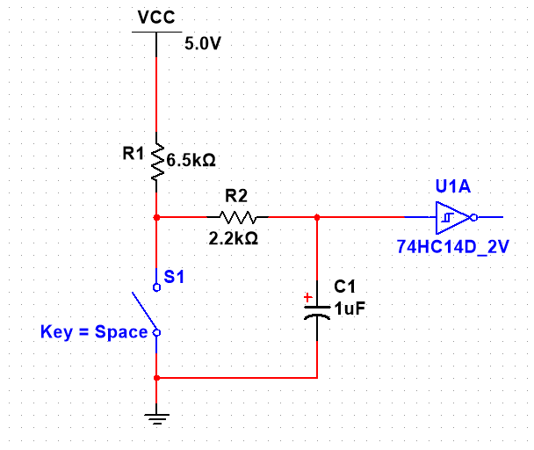
Fig 5: Circuit diagram for debouncing

Hysteresis voltage = V_{H} = V_{th,H} - V_{th,L} = 2.3 - 0.23 = 2.07 V

- Flowchart –
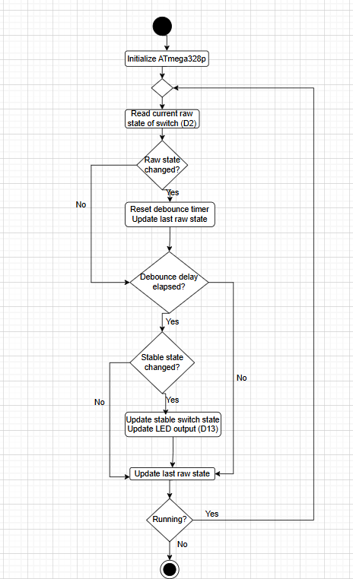
Fig 6: Flowchart for debouncing software solution

Code –
const int switchPin = 2;
const int ledPin = 13;

int switchState = LOW;
int lastSwitchState = LOW;
int rawSwitchState = LOW;
int lastRawSwitchState = LOW;

unsigned long lastDebounceTime = 0;
const unsigned long debounceDelay = 30;

void setup() {
pinMode(switchPin, INPUT_PULLUP);
pinMode(ledPin, OUTPUT);

switchState = !digitalRead(switchPin);
lastSwitchState = switchState;
digitalWrite(ledPin, switchState);
}

void loop() {
rawSwitchState = !digitalRead(switchPin);

if (rawSwitchState != lastRawSwitchState) {
lastDebounceTime = millis();
}

if ((millis() - lastDebounceTime) > debounceDelay) {
if (rawSwitchState != switchState) {
switchState = rawSwitchState;
digitalWrite(ledPin, switchState);
}
}

lastRawSwitchState = rawSwitchState;
}

Proteus simulation –
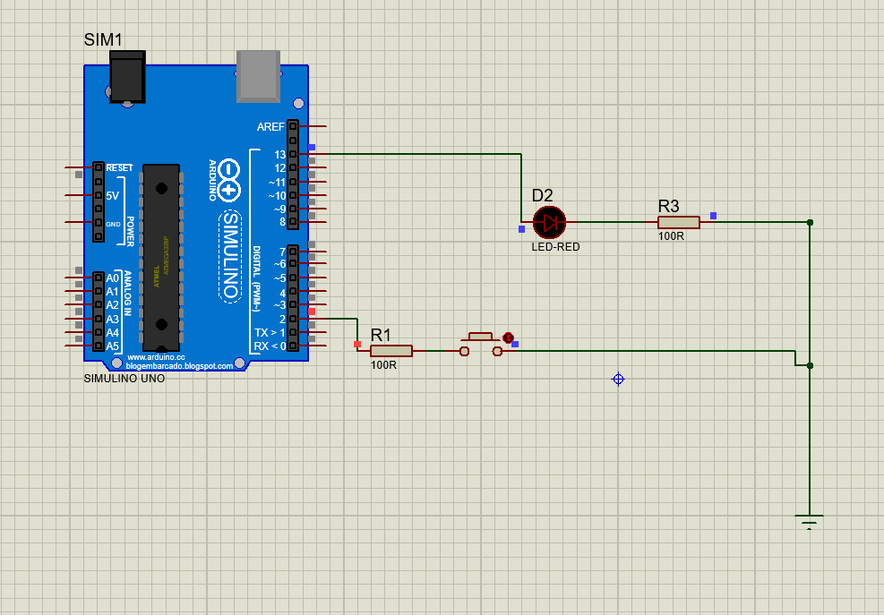
Fig 7: Switch LOW, LED LOW

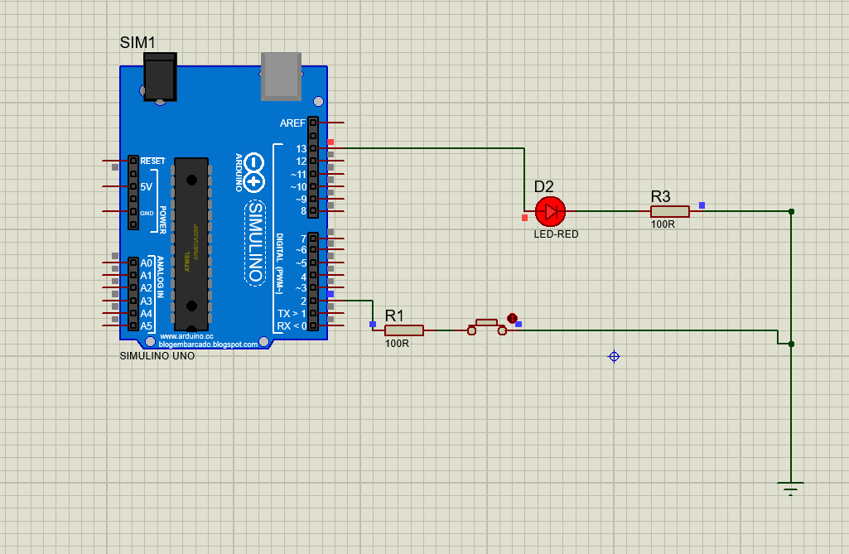
Fig 8: Switch HIGH, LED HIGH

- A biomedical engineer is to design a new laboratory where biologically hazardous materials are being used for experimental research works. As such, during the experimental works are ongoing, no one is allowed to remain inside the laboratory. To display the message that hazardous materials are being used in the laboratory, 2 lights with green and red colors are installed at the entrance door of the laboratory. When the green light is turned on, it indicates that anybody can enter the laboratory but when the red light is turned on then none can enter the laboratory. It is to be ensured that both lights can’t remain turned on at the same time and these 2 lights should be controlled using a single mechanical switch inside the laboratory, and they can only light up alternatively when the switch is pressed or depressed. The switch has already been debounced using a hardware circuit. Draw a flowchart to show the logical flow of the program and then write a program for the Arduino Uno microcontroller to operate the door lights based on the switch conditions as per the given constraints. Show the simulation results using Proteus.

Answer:
Flowchart –

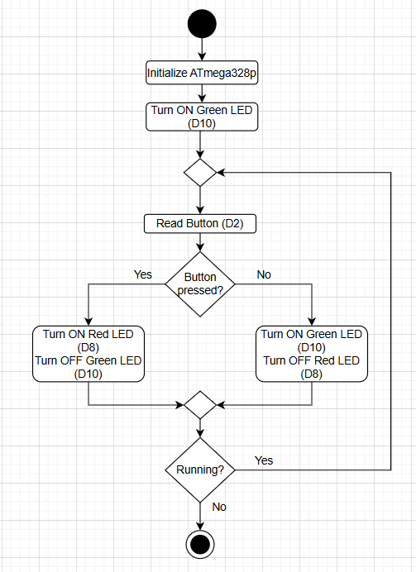
Fig 6: Flowchart for question 3

Code –
const int GREEN_LED = 10;
const int RED_LED = 8;
const int SWITCH_PIN = 2;

void setup() {
pinMode(GREEN_LED, OUTPUT);
pinMode(RED_LED, OUTPUT);
pinMode(SWITCH_PIN, INPUT_PULLUP);

digitalWrite(GREEN_LED, HIGH);
digitalWrite(RED_LED, LOW);
}

void loop() {
bool switchPressed = (digitalRead(SWITCH_PIN) == LOW);

if (switchPressed) {
digitalWrite(RED_LED, HIGH);
digitalWrite(GREEN_LED, LOW);
}
else {
digitalWrite(GREEN_LED, HIGH);
digitalWrite(RED_LED, LOW);
}
}

Proteus Simulation –
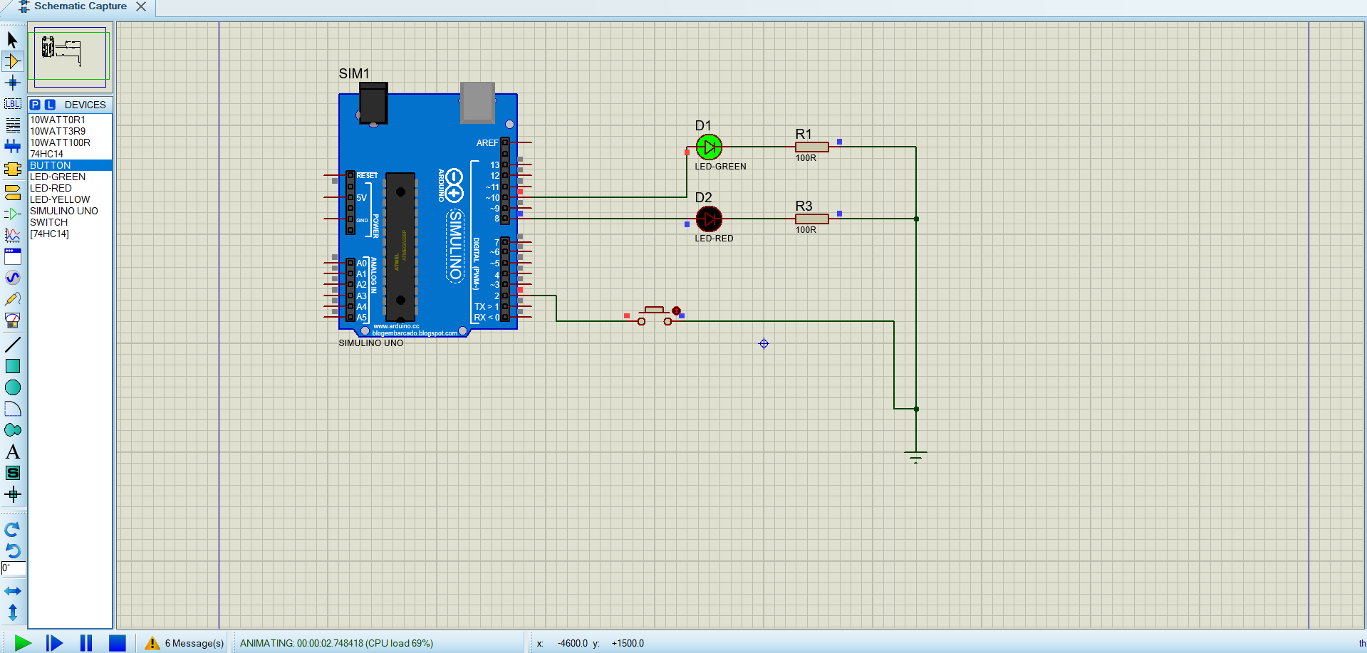
Fig 7: Green LED ON, Red LED OFF

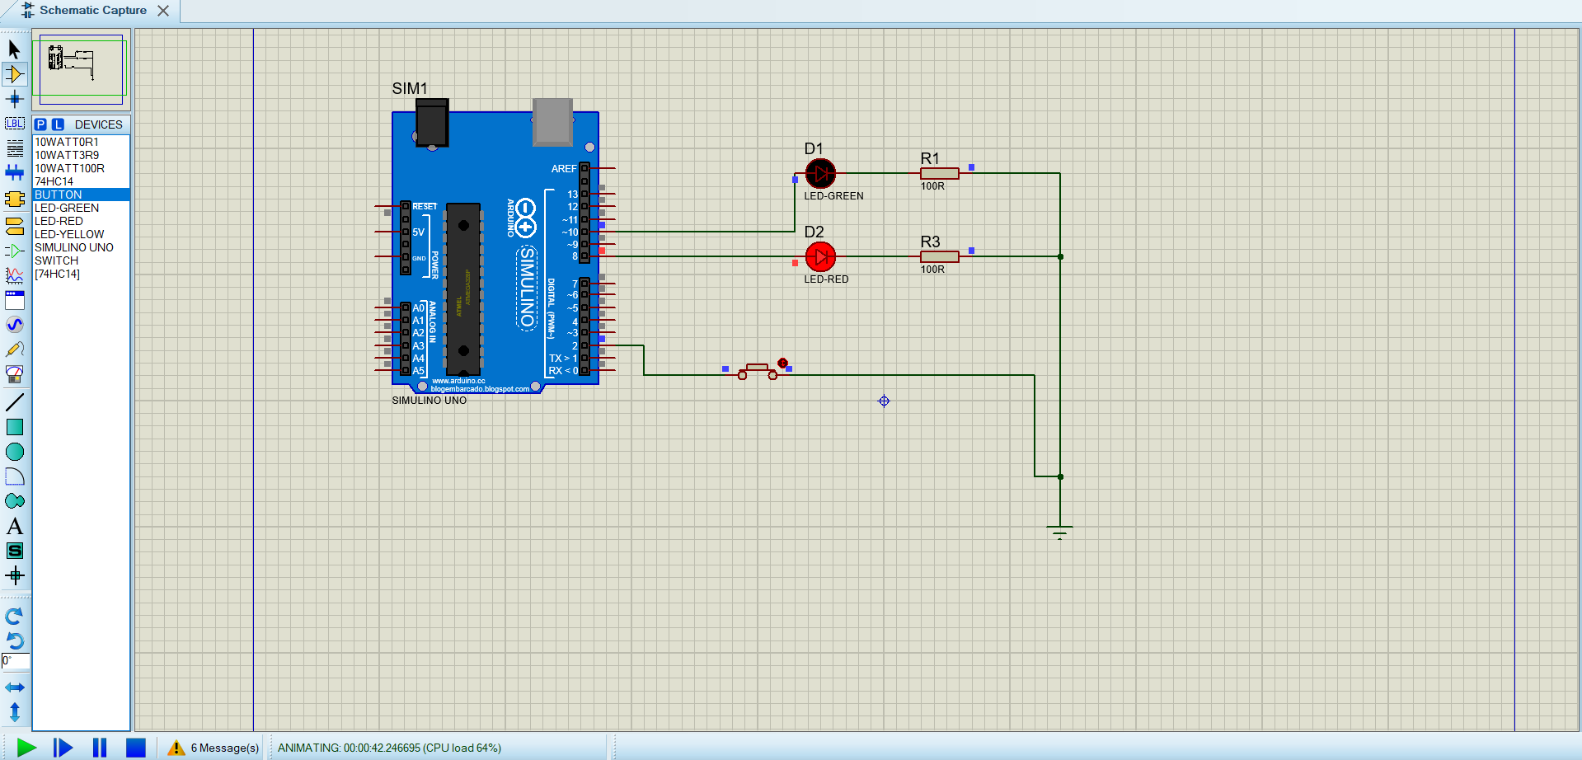
Fig 8: Red LED ON, Green LED OFF

- (a) Write an Arduino microcontroller code for a 526 ms interval LED blinking system using Timerx (x = 0-2) interrupts and a pre-scalar value of 1024. LED is connected to the pin 3 of the board. Compute the value to be loaded into the OCR2A register. Show the simulation results using Proteus.

(b) Use 2 pins in the same port for pin change interrupt. Use Arduino Pin6 and Pin7, which maps to (PD6 and PD7 in PORTD). The 2 PCINT input pins must be connected to 2 push buttons. Use the interrupt events to toggle 2 LEDs, connected to the pin pin2 and pin3 (mapped to PD2 and PD3 of PORTD) in the respective ISR handler function for each PCINT interrupt. Draw the flow chart of this program. Show the simulation results using Proteus.

(c) Use Arduino Pin2, which maps to (PD2 in PORTD) for External Interrupt Request, INT0. Use Arduino Pin2 and Pin3, which are mapped to corresponding port pins in PORTB to toggle 2 LEDs, connected to the pin2 and pin3, respectively. The INT0 external interrupt request input pin, PD2 in PORTD must be connected to a push button. Use the interrupt events in the respective ISR handler function for INT0 interrupt. Draw the flow chart of this program. Show the simulation results using Proteus.

- (a) Determine the output of the following program. Compute the duration of Arduino blinks an LED and makes the system power down. When powered down, the Arduino’s current drops from 92.6 mA to just ab mA. The supply voltage is 5.0542 V. Compute the amount of power that is saved by the Arduino during this power-down mode.

#include "LowPower.h"
#define RED_PIN 5

int red_on = 23542;
int red_off = 3546

void setup() {
pinMode(5, OUTPUT);
}

void loop() {
digitalWrite(5, HIGH);
delay(red_on);
digitalWrite(5, LOW);
delay(red_off);
LowPower.powerDown(SLEEP_4S, WDT_OFF, BOD_OFF, SPI_OFF, TWI_OFF);
}

(b) Determine the output of the following program. Compute power and energy consumption during the ON and OFF conditions as well as SLEEP modes in idle and power down states. Compute power savings.

#include “LowPower.h”

#define RED_PIN 2

int red_on = 32526
int red_off = 3566

void loop() {
pinMode(2, OUTPUT);
}

void setup() {
digitalWrite(2, HIGH);
delay(red_on); // USB Meter readings = 4.952 V, 0.7663 A)
digitalWrite(2, LOW);
delay(red_off); // USB Meter readings = 5.0426 V, 0.323 A)
LowPower.idle(SLEEP_8S, ADC_OFF, SPI_OFF); // USB Meter readings = 5.54 V, 0.0036 A)
LowPower.powerDown(SLEEP2S, WDT_OFF, BOD_OFF); // USB Meter readings = 5.026 V, 0.0056 A)
}

Answer:
ID: 22-48056-2 | pq - abcde – r
Therefore, p = 2, q = 2, a = 4, b = 8, c = 0, d = 5, e = 6, r = 2.

- Output:
The red LED is set at pin 5 and it stays ON for a duration of 23.542 seconds, then it stays off for a duration of 3.546 seconds. During each loop the Arduino then executes LowPower.powerDown(SLEEP_4S….) which means 4-second power-down sleep.
LED ON duration:
23,542 ms = 23.542 seconds

LED OFF duration:
3,546 ms = 3.546 seconds

Power-down duration: 4 Seconds.
Total Duration: 31.088 seconds.

Power Saved in Power-Down Mode: -

Given:
Active current: 92.6 mA
Power-down current: ab mA = 48 mA
Supply voltage: 5.0542 V

Power-on = VI = 5.0542 $×$ 0.0926 = 0.47W
Power-down = VI = 5.0542 $×$ 0.048 = 0.24W
Power-saved = 0.47 – 0.24 = 0.23W.

- Output:
The program begins by configuring pin 2 as an output.
The LED connected to pin 2 is then turned ON and remains on for 32.526 seconds.
After this ON period, the LED is turned OFF and stays off for 3.566 seconds.
Following the OFF interval, the Arduino enters an 8-second IDLE sleep mode where some internal modules are disabled to reduce power consumption.
After completing the idle sleep, the Arduino transitions into a deeper 2-second POWER-DOWN sleep mode.
Power Consumption:
Pon​ = 4.952×0.7663 = 3.796W
Poff​ = 5.0426×0.323 = 1.628W
Pidle ​= 5.54×0.0036 = 0.01994W
Ppd​ = 5.026×0.0056 = 0.02814W

Energy Consumption:
Eon ​= 3.796×32.526 = 123.6J
Eoff​ = 1.628×3.566 = 5.80J
Eidle ​= 0.01994×8 = 0.1595J
Epd​ = 0.02814×2 = 0.0563J

Power savings when idle -
ΔP = 3.796 − 0.01994 = 3.776W
Power savings when power down –
ΔP = 3.796 − 0.02814 = 3.768W

Until and unless specified, the digits from your ID will sit side-by-side, no multiplication among them!

